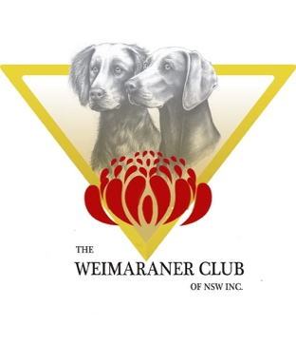Celebrating 50 Years  1971 – 2021 | WEIMARANER CLUB OF NSW INC.  MERCHANDISE ORDER FORM
 | NAME
 | POSTAL ADDRESS |  |  | STREET & NUMBER
 | SUBURB/TOWN |  |  |  |  | STATE | POSTCODE
 | PHONE |  | HOME |  | MOBILE
 | EMAIL
ORDER TOTAL
$

Ordering/Payment Details: Fill in this FORM and send your order to weinot66@bigpond.com along with a copy of your receipt. Payments can be made by EFT into the following account Weimaraner Club of NSW Inc. BSB 062-271 Account Number 00903649 OR PayPal to weiclubnsw@outlook.com Please reference the deposit 'MERCHYOURSURNAME.'
If you would like your order posted please contact BRONNIE WILSON prior to making payment as Postage and Handling fees apply.
Bronnie,s contact details:
Phone 0403344276
Email: weinot66@bigpond.com

CAP | $30.00
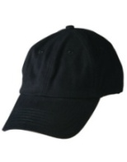 | QUANTITY:
Poly Polos  Code 7SPP  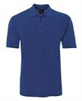 |  | ADULTS CODE 7SPP |  |  | $45
 |  | Size  Bust/Chest cm  Length cm |  |  | S  53.5  70 |  |  |  |  | M  56  72.5 |  |  |  |  |  |  | L  58.5  75 |  |  |  |  | XL  61  77.5 |  |  |  |  | 2XL  63.5  80 |  |  | 3XL  66.5  81 |  |  |  | 4XL  70  82 |  |  |  |  | 5XL  73.5  83 |  |  |  |  |  | 7XL  89.5  85
 |  | Black
Blue
White
 |  | LADIES |  |  | $45
 |  | Size  Bust/Chest cm  Length cm |  |  | 8  46  62 |  |  |  | 10  48.5  64 |  |  |  |  |  |  | 12  51  66 |  |  |  |  |  | 14  53.5  68 |  |  |  |  | 16  56  70 |  |  | 18  58.5  72 |  |  |  | 20  61  73 |  |  |  |  | 22  63.5  74 |  |  |  |  |  | 24  66  75
 |  | Black
 |  | Blue
POLAR FULL ZIP JACKET  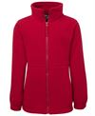 |  | ADULTS CODE 3FJ |  | $63
 |  | Size  Bust/Chest cm  Length cm |  | S  55  72 |  |  |  |  |  |  |  | M  57.5  74 |  |  |  |  |  |  | L  60  76 |  |  |  |  | XL  62.5  78 |  |  |  | 2XL  65  80 |  |  |  | 3XL  67.5  81 |  |  |  | 4XL  70  82 |  |  |  |  | 5XL  72.5  83
 |  | Black
 |  | Royal Blue
 |  | Navy Blue
 |  | LADIES CODE 3FJ1 |  | $55
 |  | Size  Bust/Chest cm  Length cm |  | 8  49  61.5 |  |  |  | 10  51.5  63.5 |  |  |  |  |  |  |  | 12  54  65.5 |  |  |  |  |  | 14  56.5  67.5 |  |  |  |  | 16  59  69.5 |  |  | 18  61.5  71.5 |  |  |  | 20  64  73.5 |  |  |  | 22  66.5  75.5 |  |  |  |  |  | 24  69  77.5
Black
Navy Blue
POLAR VEST  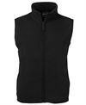 |  | ADULTS CODE 30V |  | $50
 |  | Size  Bust/Chest cm  Length cm |  | S  55  65.5 |  |  |  |  |  |  | M  57.5  67.5 |  |  |  |  |  |  | L  60  62.5 |  |  |  |  | XL  62.5  71.5 |  |  |  |  | 2XL  65  73.5 |  |  |  | 3XL  67.5  75.5 |  |  |  |  | 4XL  70  77.5 |  |  |  |  |  | 5XL  72.5  79.5
BlacK
Navy
 |  | LADIES CODE 3LV |  | $50
 |  | Size  Bust/Chest cm  Length cm |  | 8  49  59.5 |  |  |  | 10  51.5  61.5 |  |  |  |  |  |  | 12  54  63.5 |  |  |  |  |  |  | 14  56.5  65.5 |  |  |  |  | 16  59  67.5 |  |  | 18  61.5  69.5 |  |  |  | 20  64  71.5 |  |  |  |  | 22  66.5  73.5 |  |  |  |  |  | 24  69  75.5
Black
Royal Blue
Navy Blue
LAYER SOFTSHELL VEST  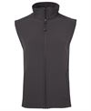 |  |  | ADULT CODE 3JVL |  |  | $80
 |  |  | Size  Bust/Chest cm  Length cm |  |  | S  54  72 |  |  |  |  |  |  | M  56.5  74 |  |  |  |  |  |  | L  59  76 |  |  |  |  | XL  61.5  78 |  |  |  | 2XL  64  80 |  |  |  | 3XL  66.5  82 |  |  |  | 4XL  69.5  83 |  |  |  |  | 5XL  72  84
 |  |  | Black
Grey
Navy
 |  |  | LADIES CODE 3LV1 |  |  | $80
 |  |  | Size  Bust/Chest cm  Length cm |  |  | 6  46  61 | 8  48  63 |  |  |  |  |  |  | 10  50  65 |  |  |  |  |  |  | 12  52  67 |  |  |  |  | 14  54.5  69 |  |  | 16  57  71 |  | 18  59.5  73 |  |  |  | 20  62  75 |  |  |  |  | 22  64.5  77 |  |  |  |  |  | 24  67  79
BlacK
Navy

FLEECE SHEPHERD JACKET  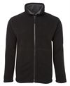 | ADULT CODE 3JS | $75
 | Size  Bust/Chest cm  Length cm | S  57.5  72 |  | M  60  74 |  | L  62.5  76 |  | XL  65  78 |  | 2XL  67.5  80 |  | 3XL  70  82
 | Black/Grey
 | Navy
 | LADIES CODE 3JLS | $75
 | Size  Bust/Chest cm  Length cm | 8  48  61 | 10  50.5  63 |  | 12  53  65 |  | 14  55.5  67 |  | 16  58  69 | 18  60.5  71 | 20  63  73
 | Black/ Charcoal
 | Navy/White
Fleece Shepherd VEST  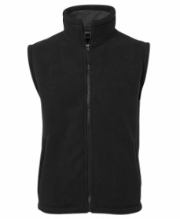 | ADULT CODE 3SV | $65
 | Size  Bust/Chest cm  Length cm | S  57.5  72 |  | M  60  74 |  | L  62.5  76 |  | XL  65  78 |  | 2XL  67.5  80 |  | 3XL  70  82
 | Black/Charcoal

FLEECE SHEPHERD HOODIE  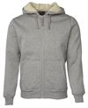 | ADULT CODE 3SH | $80
 | Size  Bust/Chest cm  Length cm | S  55  70 | M  57.5  72 | L  60  74 | XL  62.5  76 | 2XL  65  78 | 3XL  67.5  80 | 4XL  70  81 | 5XL  72.5  82
 | Black/ Natural
LAYER SOFT SHELL JACKET
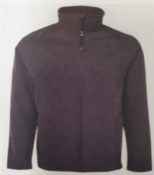
ADULT CODE  3LJ | $90
Size  Bust/Chest cm  Length cm | S  54  72 |  | M  56.5  74 |  | L  59  76 |  | XL  61.5  78 |  | 2XL  64  80 |  | 3XL  66.5  82 |  | 4XL  69.5  83 |  | 5XL  72  84
Black
Grey
LADIES CODE 3LJ1 | $90
Size  Bust/Chest cm  Length cm  Black  GREY | 6  46  61 | 8  48  63 |  | 10  50  65 |  | 12  52  67 |  | 14  54.5  69 | 16  57  71 | 18  59.5  73 |  | 20  62  75 |  | 22  64.5  77 |  | 24  67  79

WE ALSO OFFER KENNEL PREFIXES EMBROIDED ON THE BACK OF THE CLOTHING FOR A FLAT RATE $20 PLEASE LET ME KNOW AND PAY WITH YOUR ORDER.
KENNEL PREFIX:
COLOUR THREAD:

